**Assignment 2**

**October 16, 2020**

**David Oyedele**

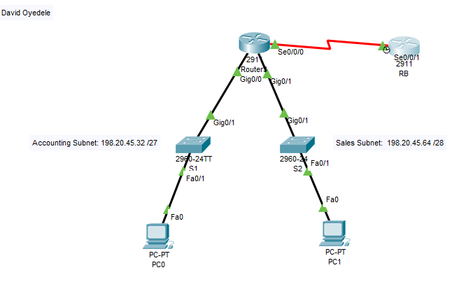

**Router RA Configuration**

**Router>en**

**Router#config t**

**Enter configuration commands, one per line. End with CNTL/Z.**

**Router(config)#hostname RA**

**RA(config)#int G0/0**

**RA(config-if)#ip add 198.20.45.33 255.255.255.224**

**RA(config-if)#description link to Accounting Subnet**

**RA(config-if)#int G0/1**

**RA(config-if)#ip add 198.20.45.65 255.255.255.240**

**RA(config-if)#description link to Sales Subnet**

**RA(config-if)#int S0/0/0**

**RA(config-if)#ip add 10.1.1.49 255.255.255.252**

**RA(config-if)#description link to RB**

**RA(config-if)#no shutdown**

%LINK-5-CHANGED: Interface Serial0/0/0, changed state to down

**RA(config-if)#int G0/1**

**RA(config-if)#no shutdown**

**RA(config-if)#**

%LINK-5-CHANGED: Interface GigabitEthernet0/1, changed state to up

%LINEPROTO-5-UPDOWN: Line protocol on Interface GigabitEthernet0/1, changed state to up

**RA(config-if)#int G0/0**

**RA(config-if)#no shutdown**

RA(config-if)#

%LINK-5-CHANGED: Interface GigabitEthernet0/0, changed state to up

%LINEPROTO-5-UPDOWN: Line protocol on Interface GigabitEthernet0/0, changed state to up

**RA(config-if)#exit**

**RA(config)#line con 0**

**RA(config-line)#password cisco**

**RA(config-line)#login**

**RA(config-line)#exit**

**RA(config)#line vty 0 4**

**RA(config-line)#password cisco**

**RA(config-line)#login**

**RA(config-line)#exit**

**RA(config)#banner motd $ This Router Was Configured by David Oyedele $**